304 Not Modified Assertion Failure for Category ID 6327
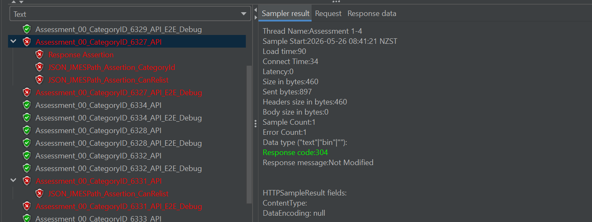

CanRelist Assertion Failure for Category ID 6331

